Julfikar Mahmud

Md Julfikar Mahmud

Student   
Software Engineering & Digital System Security

**Summary:** In this task I have used Microsoft Access Database and Visual Studio. Unit testing is also performed as TDD(Test Driven Development). In the variables screenshot I have shown the global variables that I have used in my program. Inventory.cs is the file for all my declaration of variables, accessors, mutators and unit test components. In the Broker.cs I have declared the connection name, connection type, connection string, all insert and updating functions. In the form.cs all my button functions are implemented. All the screenshots of performing functions and implementation are given below.

**[IMPORTANT] In the connection string, the directory name is set according to my computer’s settings. If the program needs to be run in another computer, the directory must be changed otherwise the program will have an error. The connection string must be changed in the ConnectionString.udl which is located at the main directory of the program and then in the connection string in the broker.cs and inventory.cs**

**Variables:**

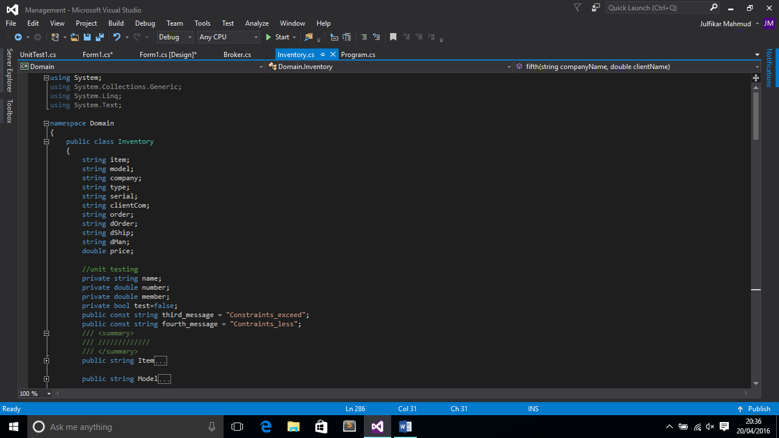

**Accessors and Mutators:**

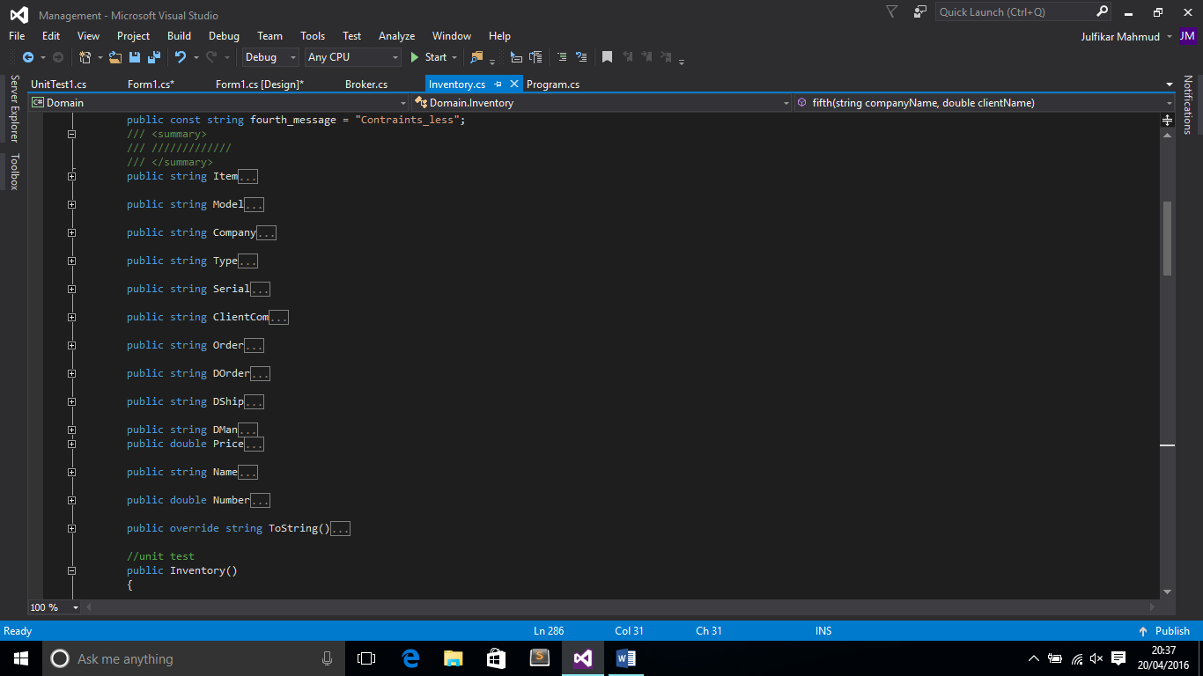

**First tab to entry the inventory items.**

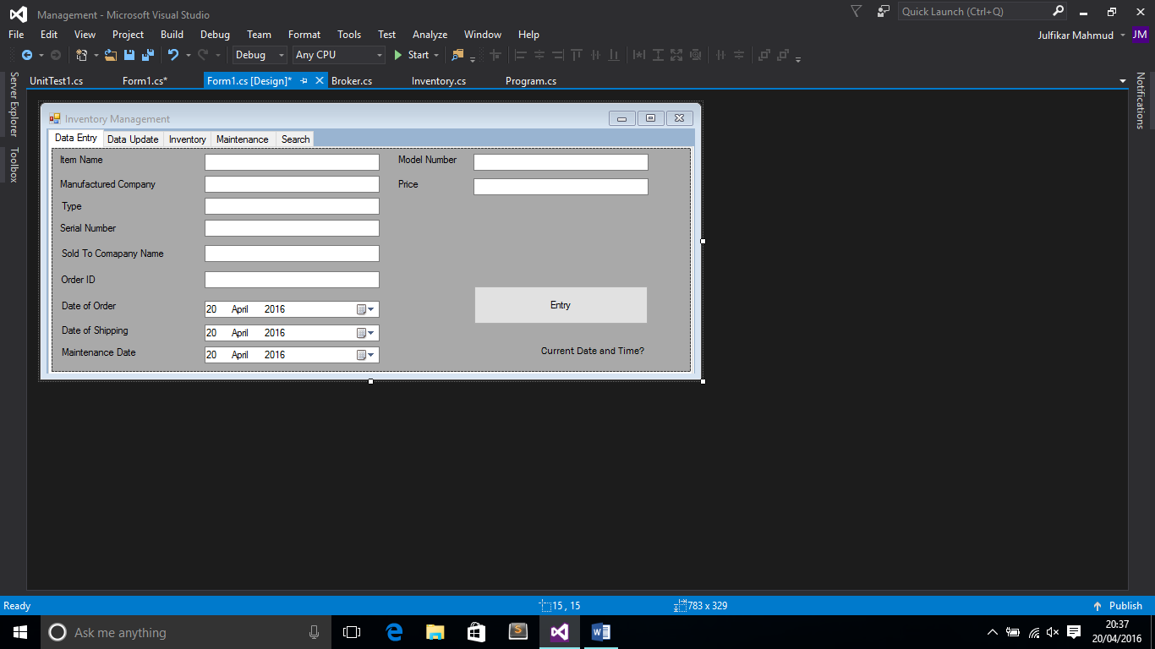

**In this part we can do updating and deleting records by selecting them from the comboBox.**

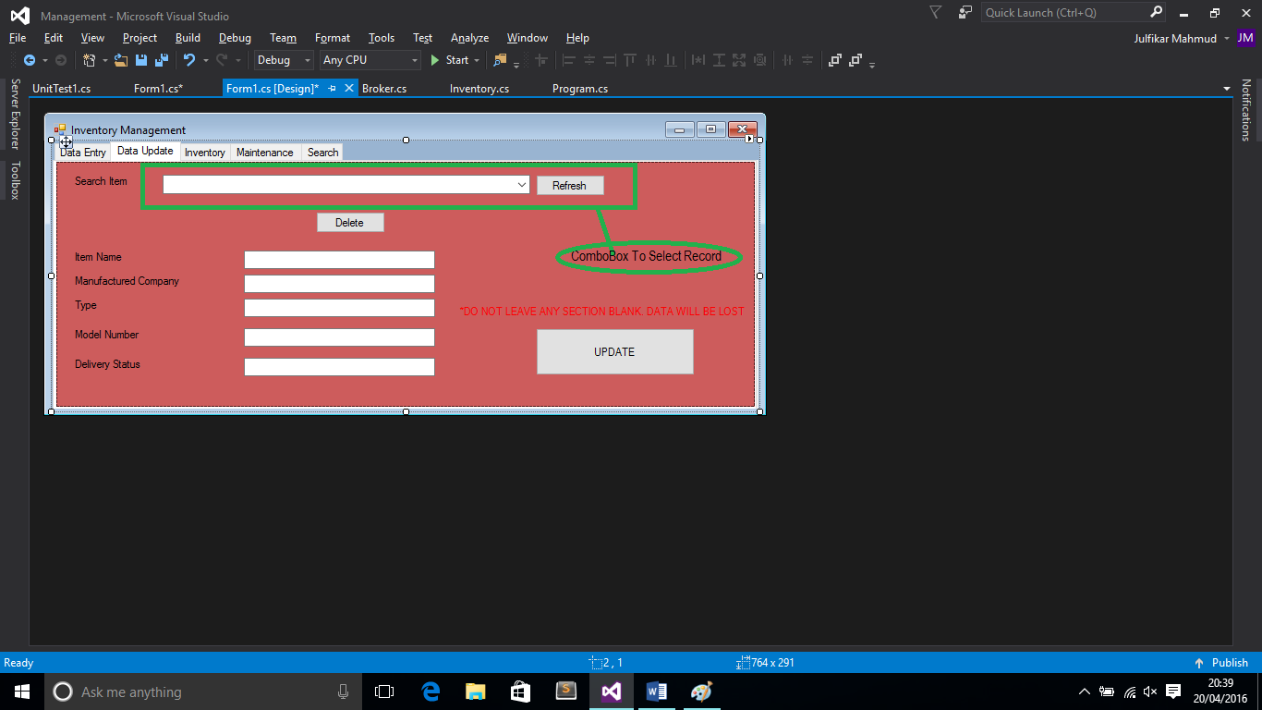

**Here, by pressing the sync button we can get the total records of sql table in the gridview box. If the table is available, it will show messagebox.**

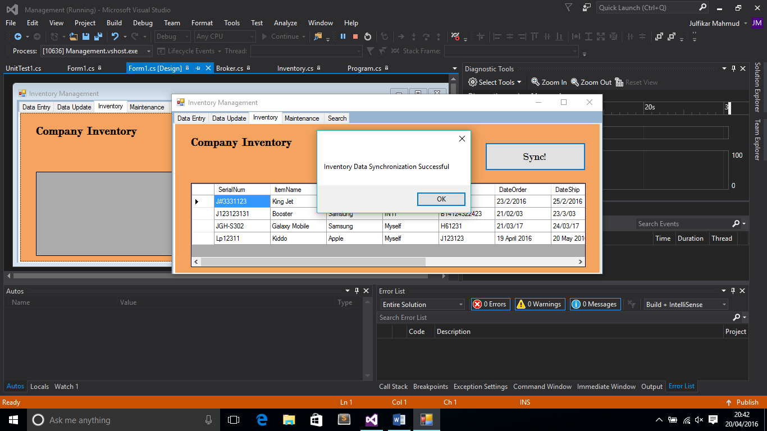

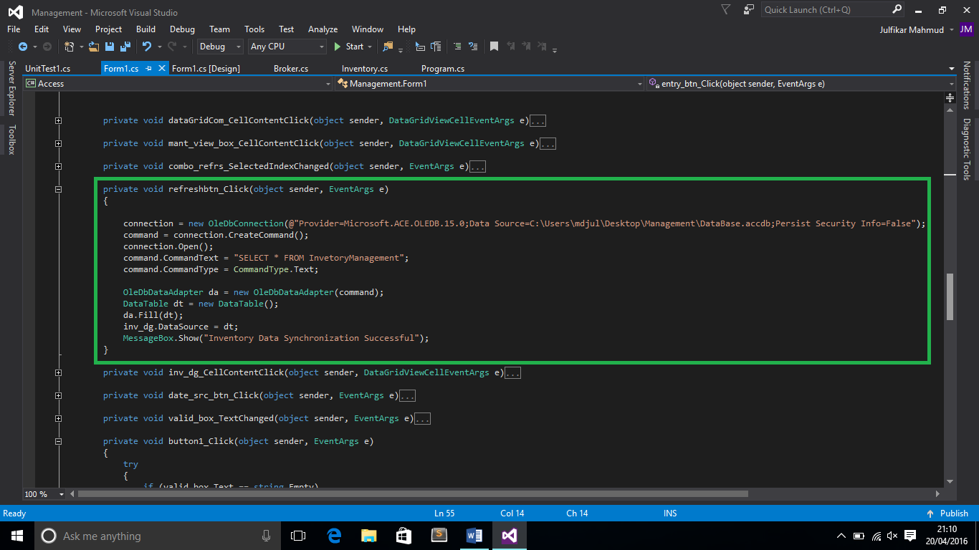

**In this part, we can search any item by their type and the record will be shown in the datagridview.**

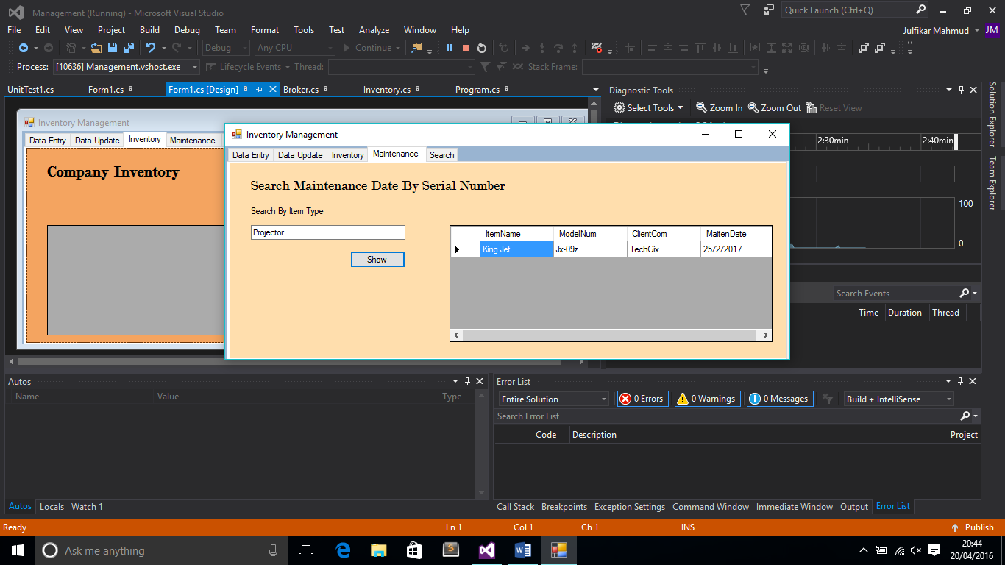

**In this tab, user can search the record by inputting the company name and can be seen in the data grid view box.**

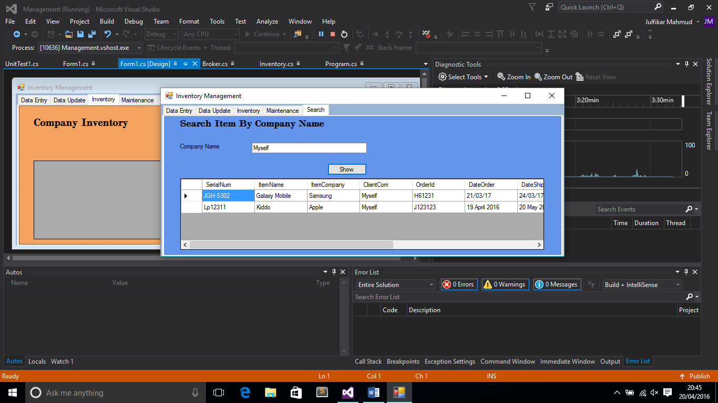

Every text box those are used here all are under validation. So if the user input doesn’t match the criteria, an error message will be shown.

**If the user try string to put in price box, an error message will be given.**

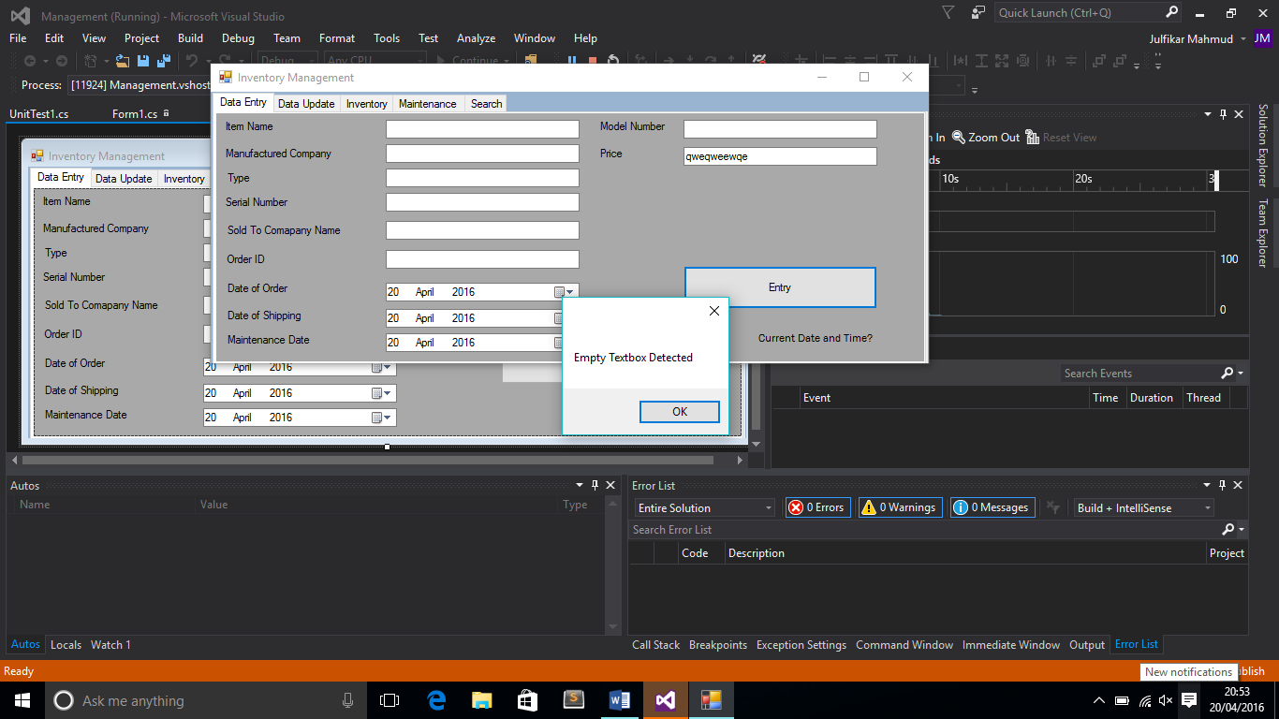

**For updating part if the user leaves any box blank, an error message will also be given to notify the user.**

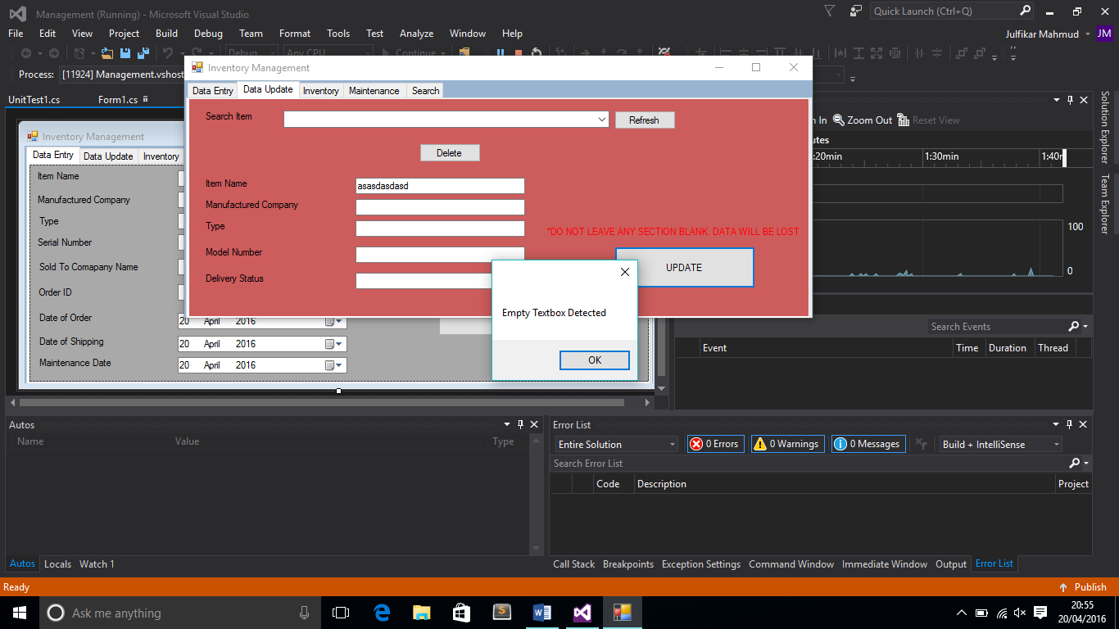

**If the user leaves the search box blank and click the SHOW button, a validation message will be thrown to the user.**

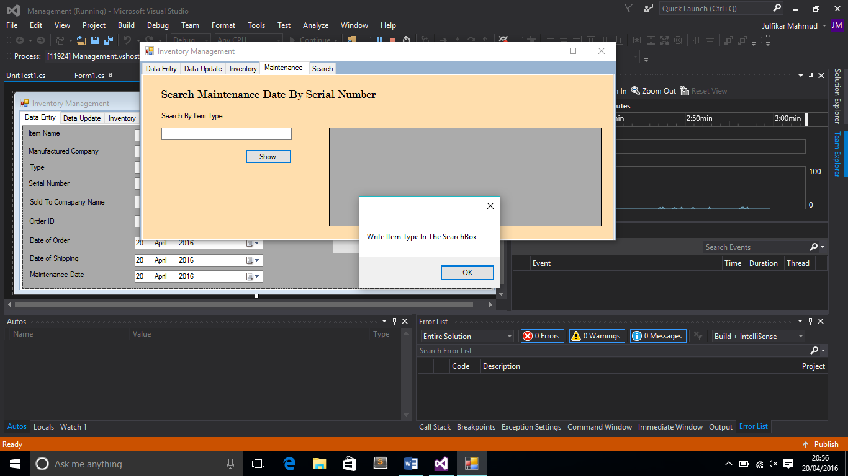

**The connectTo() is the function to set the directory of the database and the connection string. And the broker function to call the connectionTo() everytime at the starting of the program.**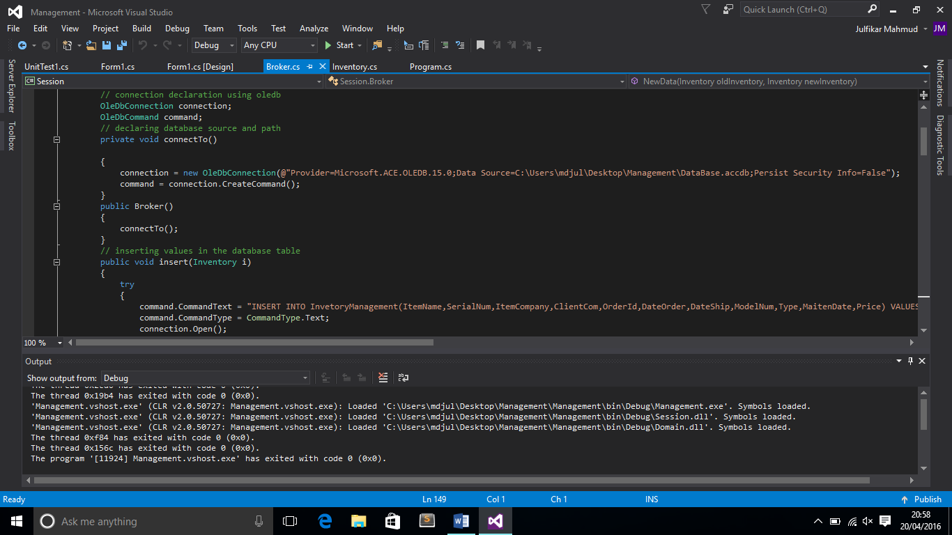

**The insert funtion to insert all records in to the database with sql syntax.**

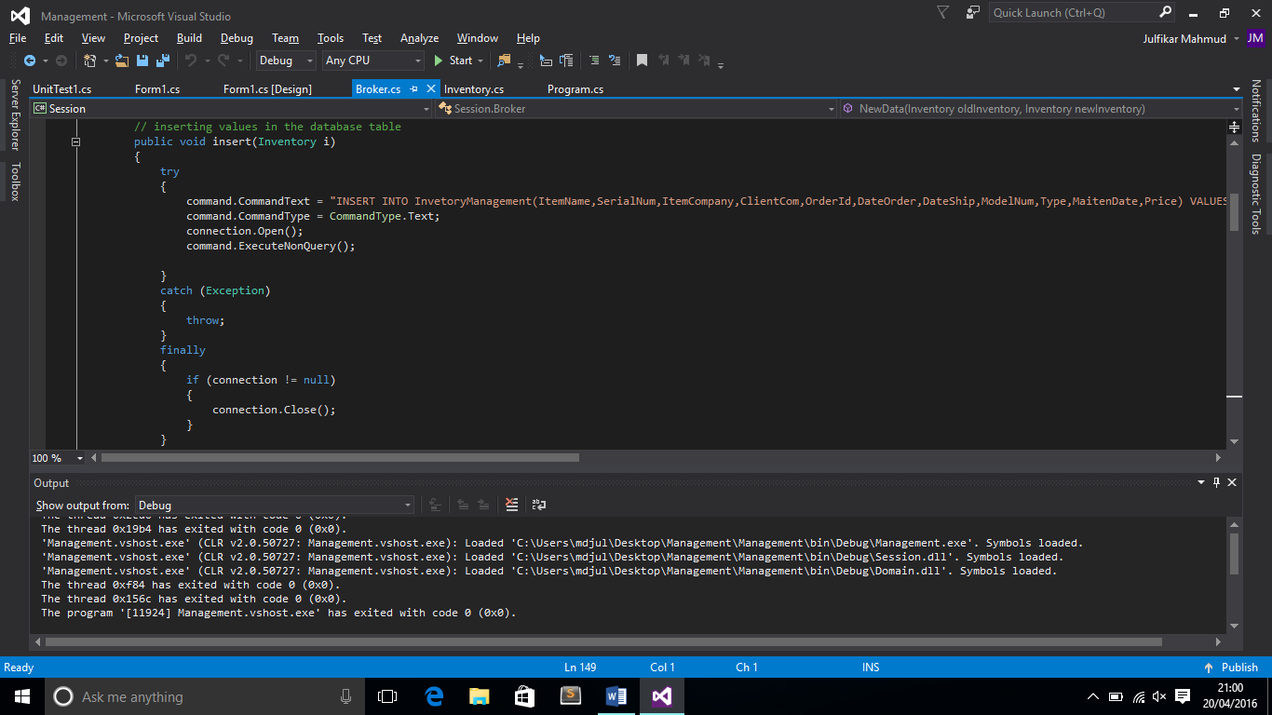

**So when the Entry button will be pressed all the data will be inserted into the database.** 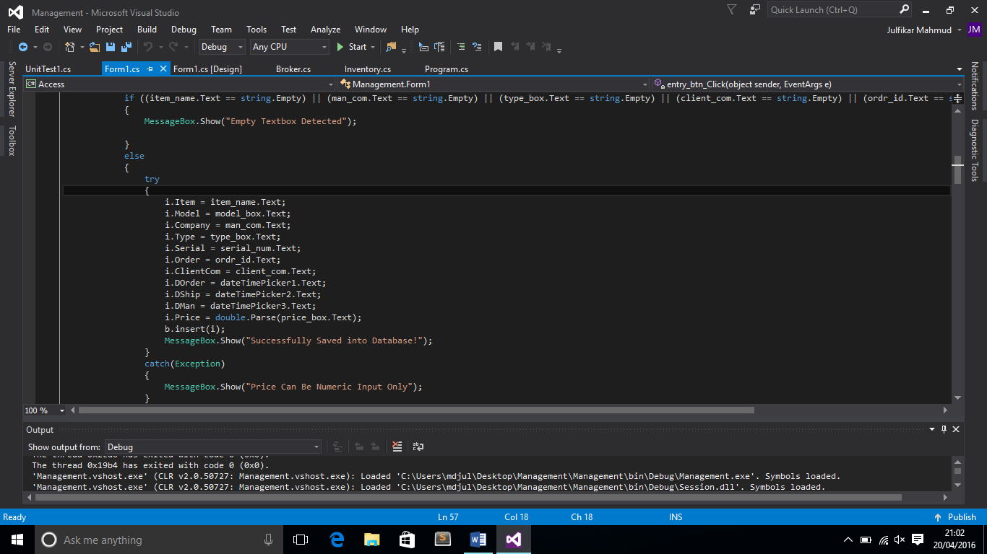

**The edit function is to update all the records as the user selected.** 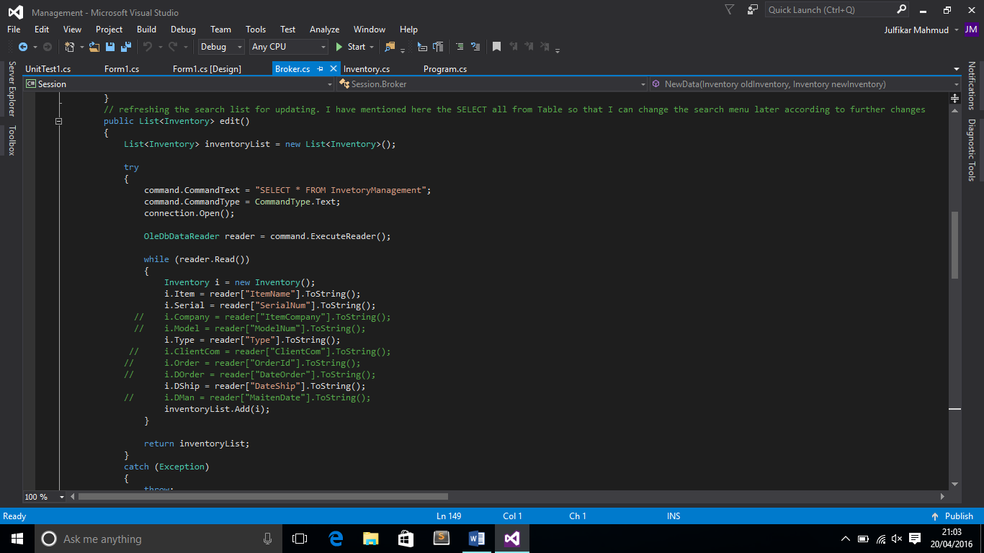

**So when the update button will be clicked, all records will be updated.** 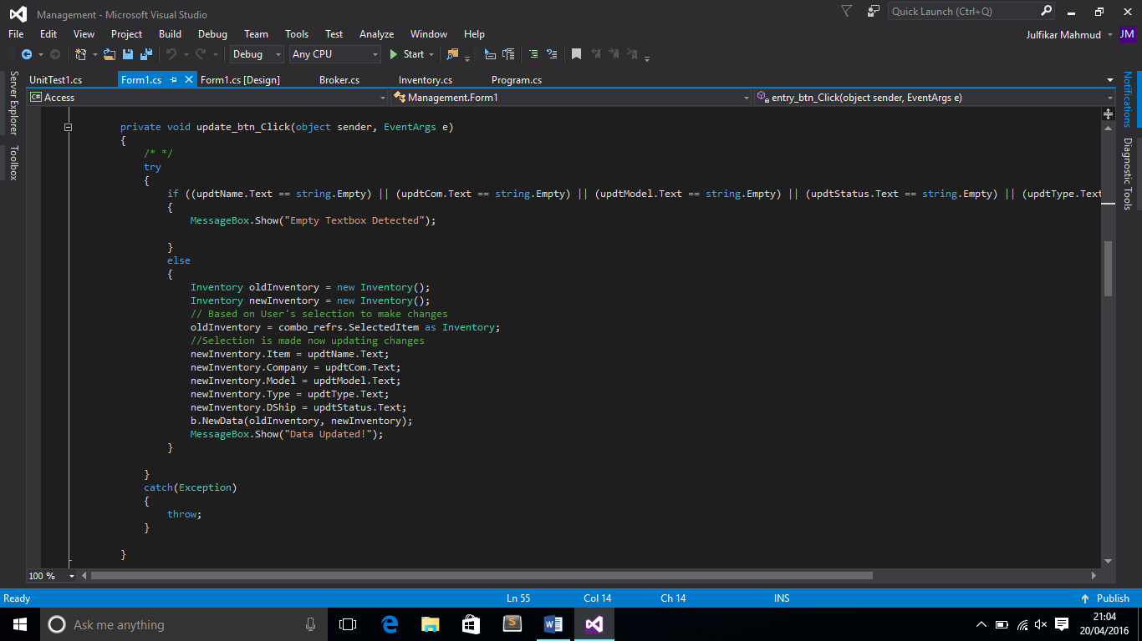

**The “1” is to refresh the comboBox by calling edit function and the “2” is to delete the data from the record as selected by the user. All values in the comboBox will be passed by the override string ToString() function.**

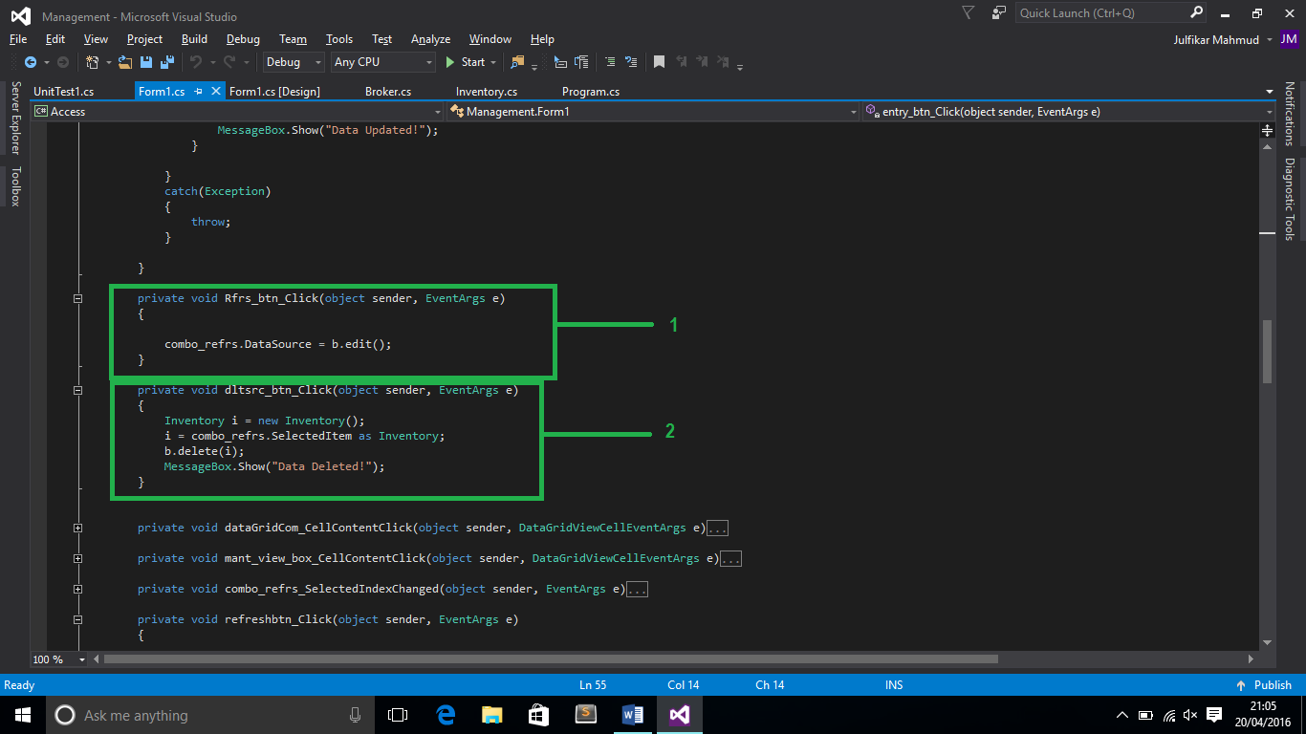

**Unit Testing:**

**The unit testing is referenced to the Inventory class. FIVE classes are being tested here.**

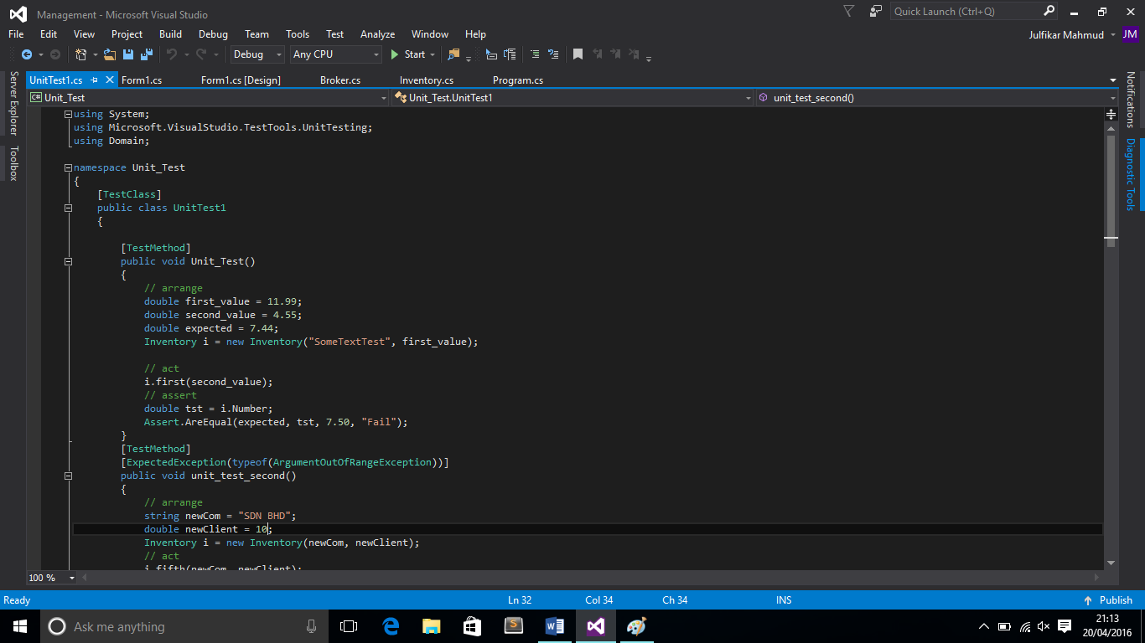

**The first test does the price testing if the price is negative or not.**

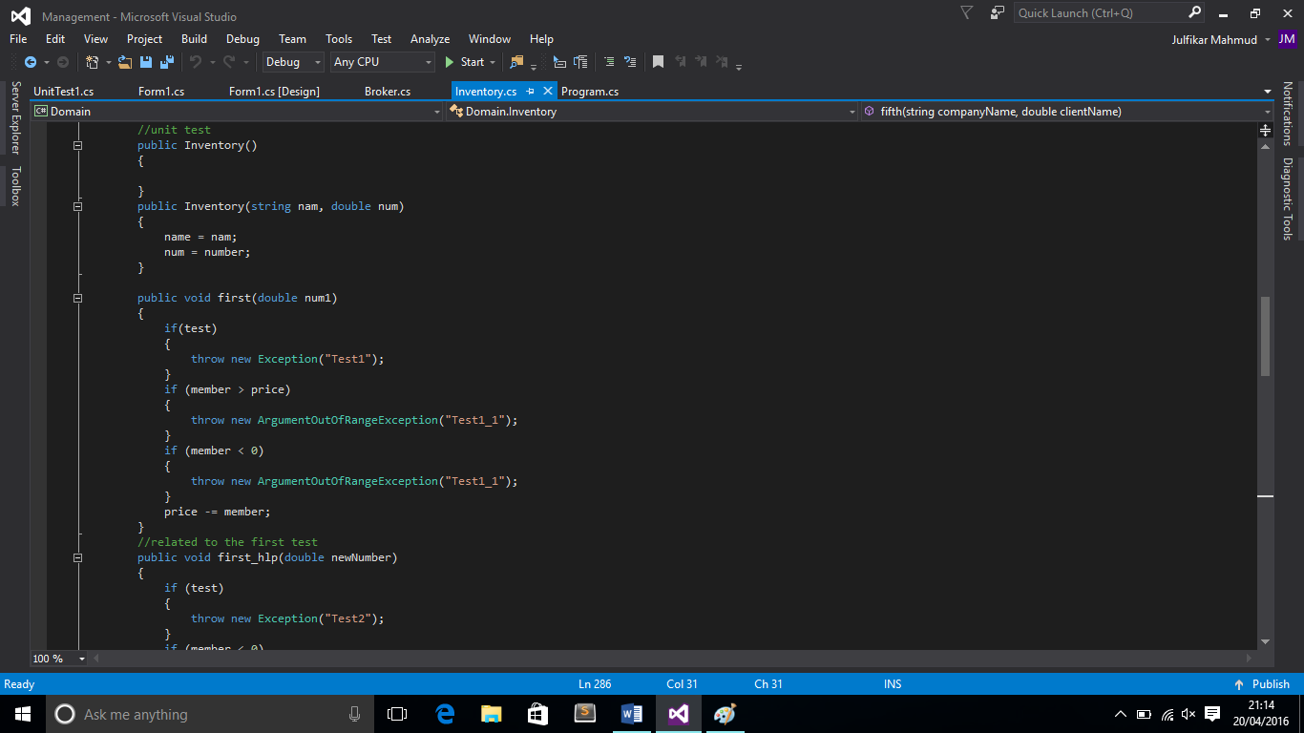

**The second test does the checking price calculation.**

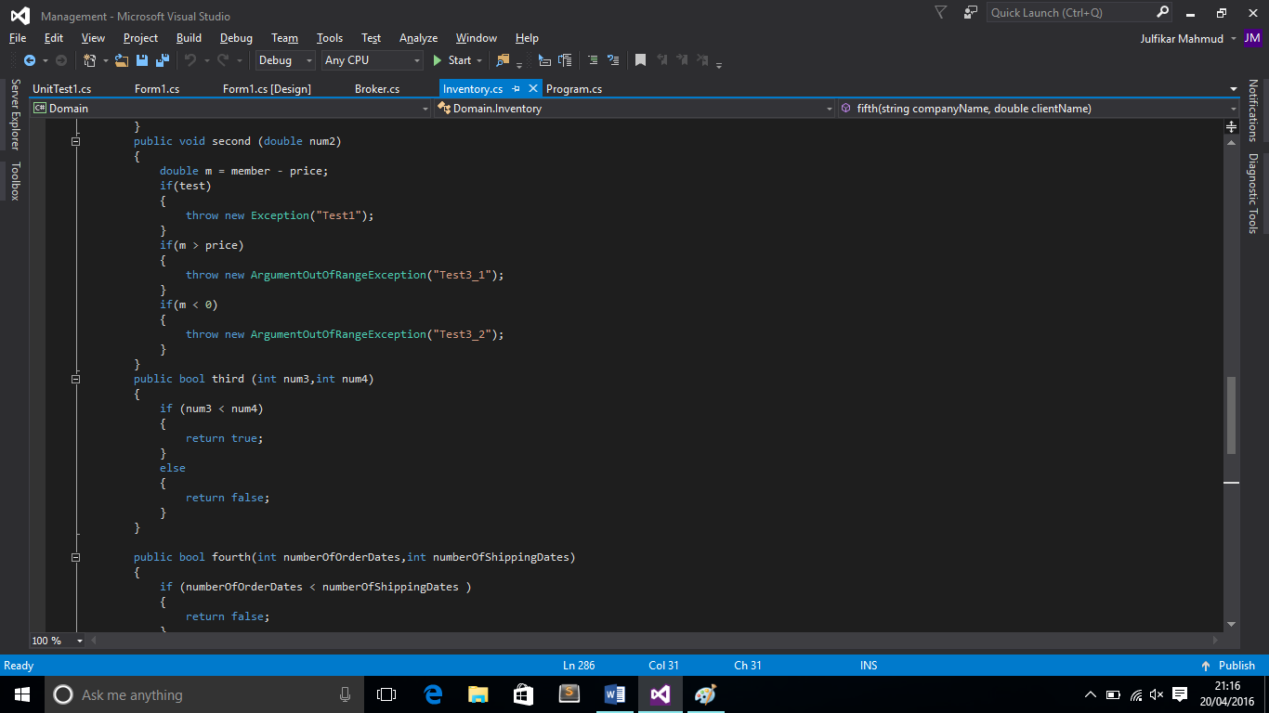

**The third test does if the inventory items are more or less the than stock numbers.**

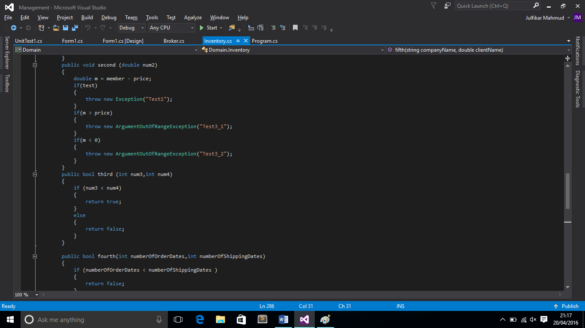

**The fourth test does testing of the company name which can’t be anything except string.**

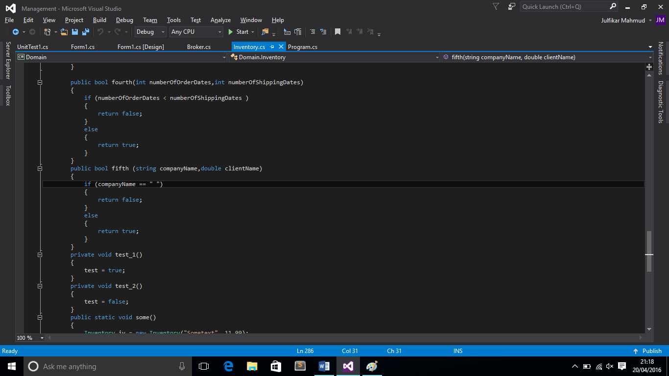

**The fifth test does the validation if the records of the order dates are similar to the maintenance date or not.**

